Question 1: In the university of Rwanda, we consider the following statements to be valid in academic affairs.

- University has many colleges
- College has schools
- A school contains many departments
- Each department can offer any number of courses
- Many instructors can work in a department
- An instructor can work only in one department
- For each department there is a Head
- An instructor can be head of only one department
- Each instructor can take any number of courses
- A course can be taken by only one instructor
- A student can enroll for any number of courses
- Each course can have any number of students
  - From the above statements, identify the entities.
  - From the statements above and identified entities, identify the relationships.
  - Identify the key attributes for each entity.
  - Draw the complete ER diagram
  - Identify weak entity, if applicable in the context given above.

Question 2: An e-commerce company is designing a database to manage its inventory. The initial design includes the following table:
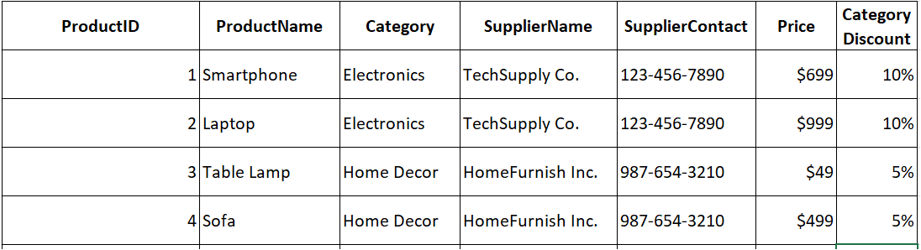

- Identify and explain the normalization issues in the given table. Suggest how the table can be normalized to the Third Normal Form (3NF).

